

**UNIVERSITY OF PETROLEUM & ENERGY STUDIES**

**Dehradun**

# Docker

**Experiment**

**Name: Harshil Bhardwaj**

**Course: B. TECH CSE DevOps (2018-22)**

**Roll no.: R171218045**

**Sapid: 500068580**

**Experiment- 3**

Check if any container is running

Run command – $ docker ps

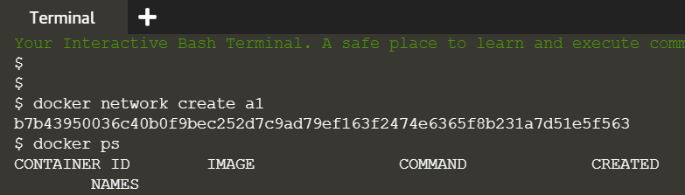

Creating a container

Run command – $ docker run –d –name=b1 –net=a1 redis

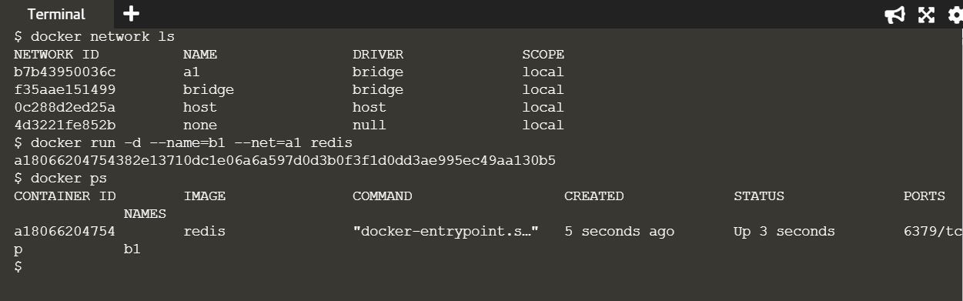

To check IP address

Run command - $ docker inspect a180

(Note : a180 is unique initials of container ID you want ip)

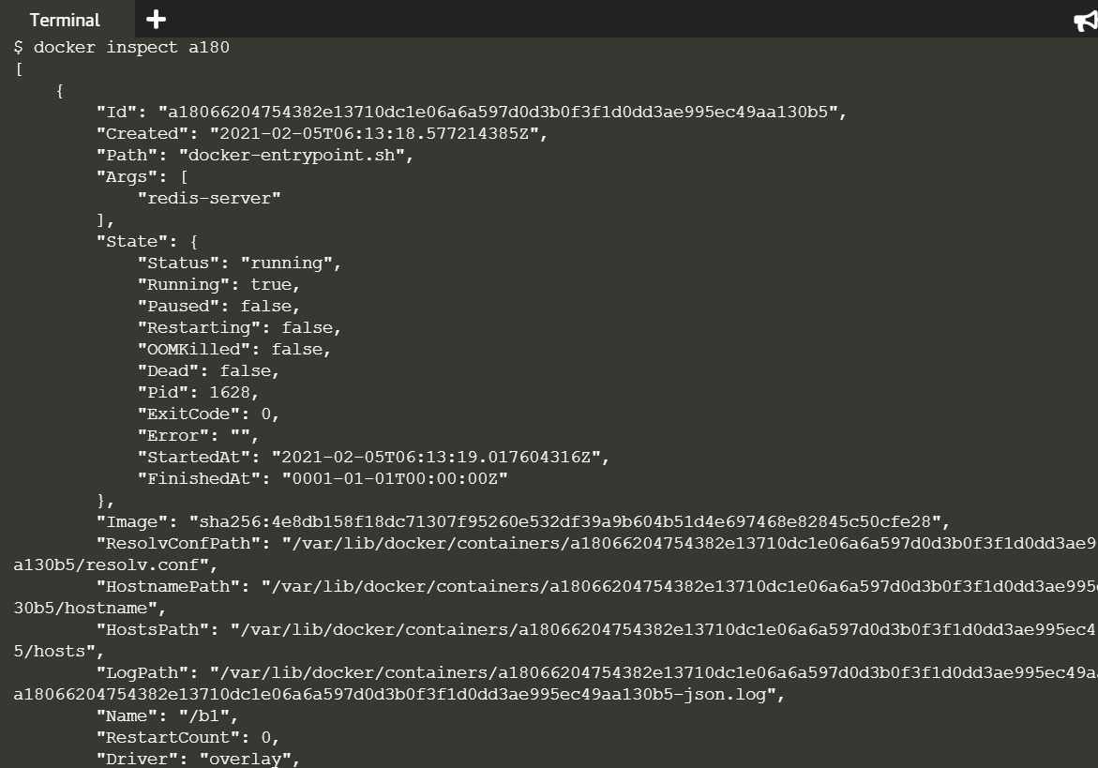

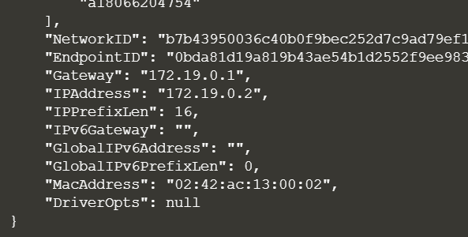

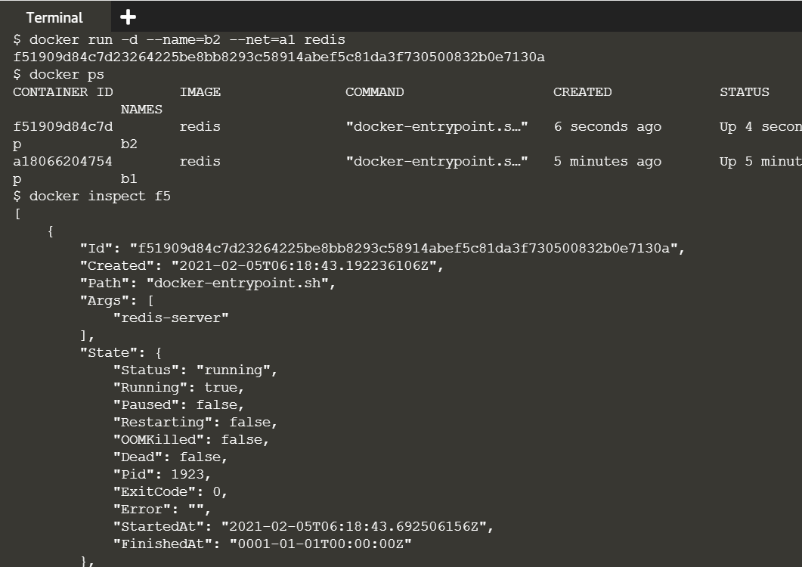

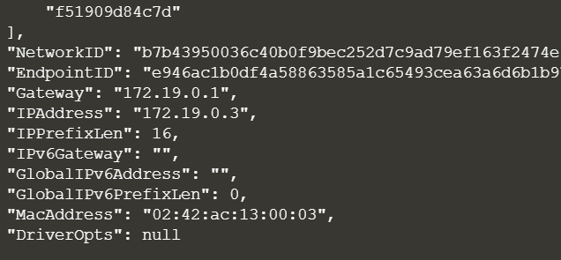

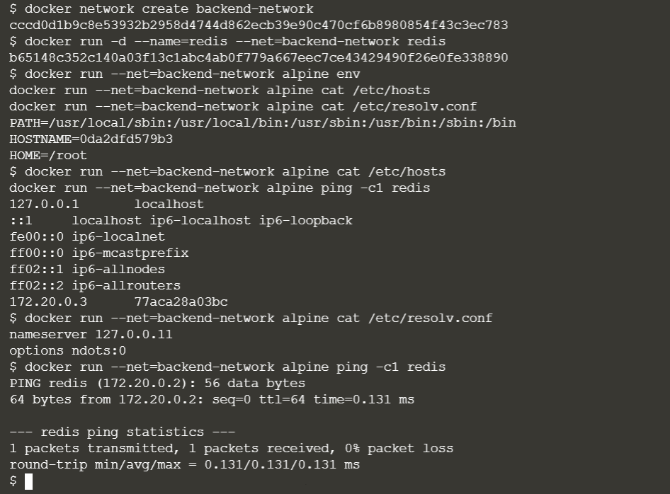

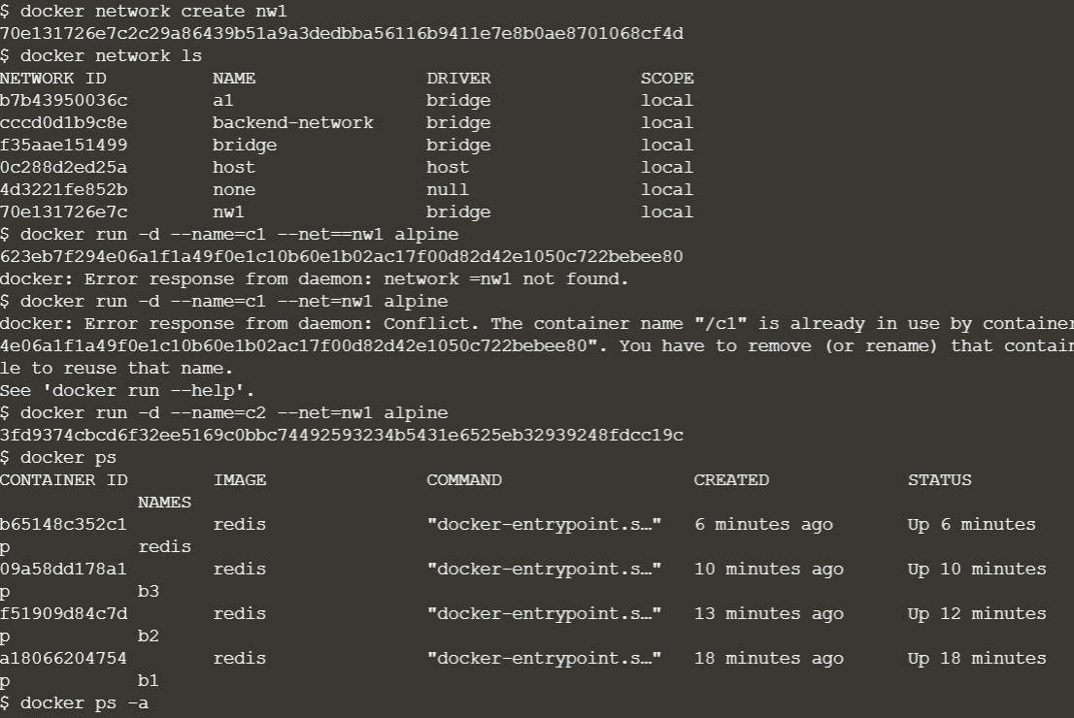

Ping network

$ docker run –name=c3 –net=backend-network alpine ping redis

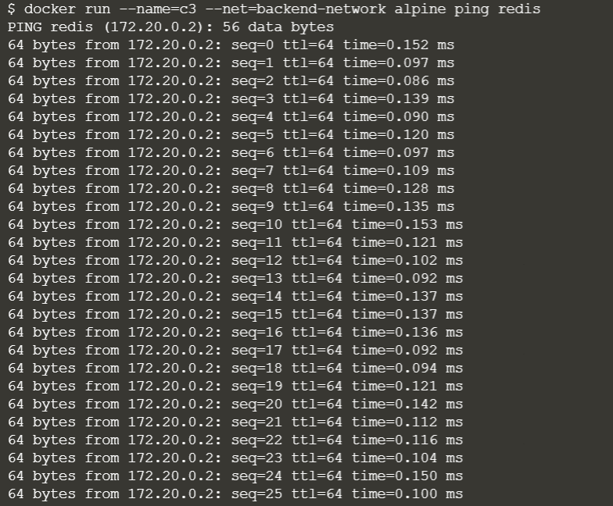



Create a network

$ docker network create backend-network

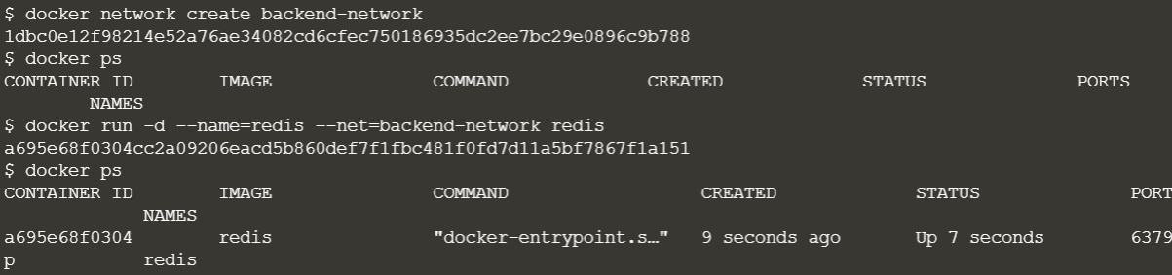

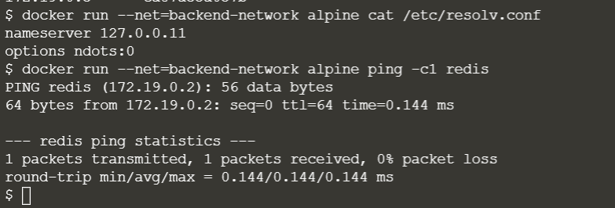

Create a network

$ docker network create frontend-network

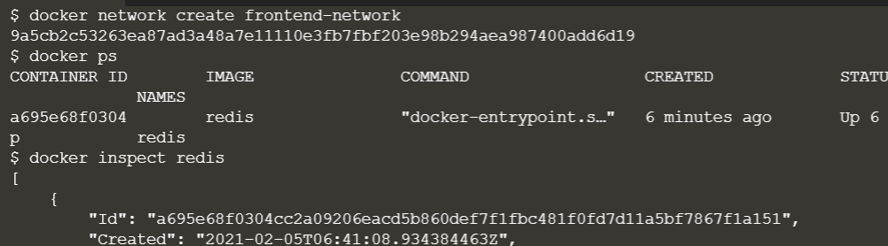

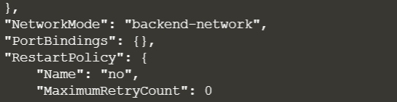

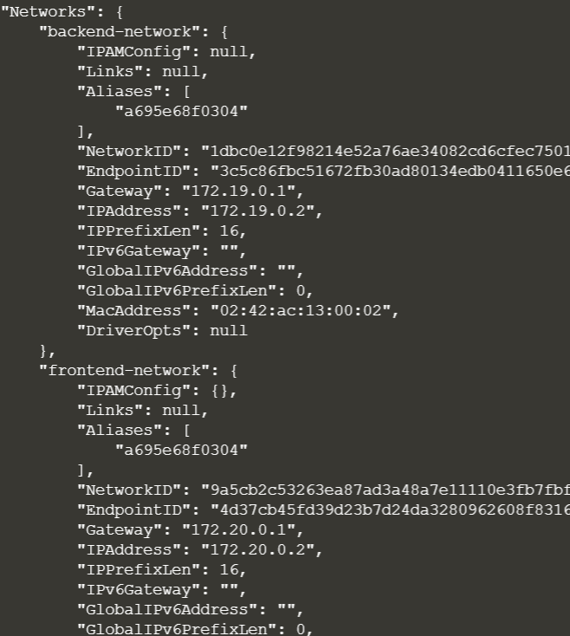

$ docker run –d –p 3000:3000 –net=frontend-network katacoda/redis-node-docker-example

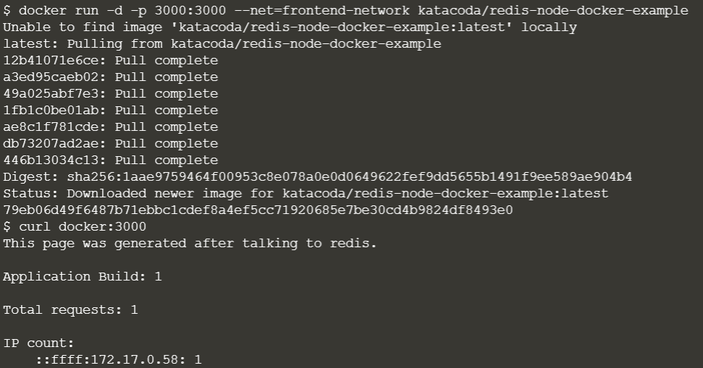

To create a network

$ docker network create frontend-network

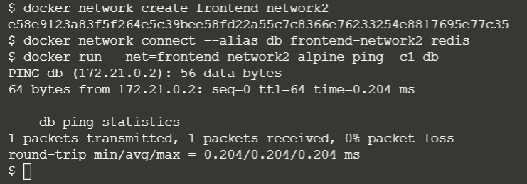

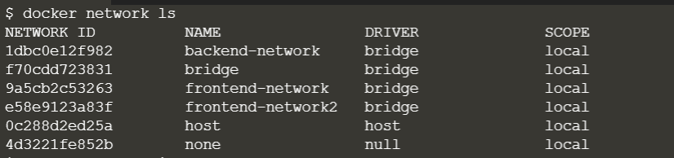

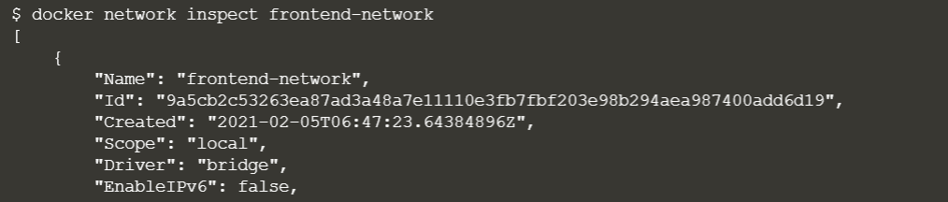

To disconnect from server

$ docker network disconnect frontend-network redis

(frontend-network is name of network)

